


Information Sciences 141 (2002) 61–79

www.elsevier.com/locate/ins

Schedulable region for VBR media
transmission with optimal resource
allocation and utilization^{q}

Ray-I Chang *, Meng-Chang Chen, Jan-Ming Ho,
Ming-Tat Ko
Department of Information Management, National Central University, Chung-Li, and Academia
Sinica, Institute of Information Science, Nankang, Taipei 115, Taiwan, ROC
Received 17 November 1999; received in revised form 23 December 2000; accepted 8 May 2001

Abstract
Media data are variable-bit-rate (VBR) in nature due to the coding and compression
technologies applied. As VBR streams are complicated for network management, dif-
ferent approaches were proposed to shape the VBR stream as a transmission schedule
with smoothed traﬃc burst. In this paper, instead of giving a ﬁxed schedule result, a
novel traﬃc shaping scheme is proposed to decide a schedulable region for all optimal
transmission schedules that provides the minimal allocation and maximal utilization of
system resources (such as network bandwidth, initial delay and client buﬀer). Experi-
ments have shown that our obtained shaping results show dramatic improvements than
that of conventional approaches in both the client buﬀer size and the network idle rate
achieved. Based on the schedulable region provided, the ready time and deadline for
each media packet can be precisely speciﬁed to support real-time network scheduling
and error control. It allows users to determine their own optimal schedules under
various quality-of-service (QoS) requirements and resource constraints. 2002 Else-
vier Science Inc. All rights reserved.

Keywords: Traﬃc engineering; Traﬃc shaping/smoothing; Multimedia; Real-time
networking

q This work was partially supported by NSC under grants NSC88-2213-E-001-011 and NSC88-
2213-E-001-012.
* Corresponding author. Tel.: +886-2-2788-3799; fax: +886-2-2782-4814.
E-mail address: william@iis.sinica.edu.tw (R.-I. Chang).

0020-0255/02/$ - see front matter 2002 Elsevier Science Inc. All rights reserved.
PII: S 0 0 2 0 - 0 2 5 5 ( 0 1 ) 0 0 1 9 1 - 8

62

1. Introduction

R.-I. Chang et al. / Information Sciences 141 (2002) 61–79

Recently, multimedia applications such as digital library, home shopping,
distance learning, video-on-demand (VOD), and video-conferencing (VC) have
attracted great attentions. In these applications, media data such as audio and
video are transmitted from server to clients via network according to some
transmission schedules. Diﬀerent from the conventional data streams, end-to-
end quality-of-service (QoS) is necessary for media transmission to provide
jitter-free playback. As network resources are allocated exclusively in ﬁxed-size
chunks to serve diﬀerent data streams, it is simple to support constant-bit-rate
(CBR) transmission. Grossglauser and Keshav [12] have investigated the per-
formance of CBR traﬃc in a large-scale network with many connections and
switches. They concluded that the network queuing delay for CBR transmis-
sion is less than one cell time per switch even under heavy loading. However,
media streams are notably variable-bit-rate (VBR) in nature due to the coding
and compression technologies applied [11,12]. For example, in an MPEG-1
movie, the average frame size is usually less than 25% of its maximal frame size.
The conventional network service model that allocates a CBR channel to
transmit the VBR stream by stream’s peak data rate would be a waste of
bandwidth. In past years, diﬀerent traﬃc shaping approaches were proposed to
reduce the traﬃc burst. Instead of giving a ﬁxed transmission schedule, we try
to decide the upper bound and the lower bound for all transmission schedules
that provides the optimal resource allocation and utilization in this paper. It is
called the schedulable region of optimal transmission schedules (or schedulable
region, for short). Based on the schedulable region provided, the ready time and
deadline for each media packet can be precisely speciﬁed to support real-time
network scheduling and error control. It allows users to determine their own
optimal schedules under various QoS requirements and resource constraints.
In a multimedia system, we generally measure the performance of a trans-
mission schedule by the following four indices: peak bandwidth, network uti-
lization, initial delay time, and client buﬀer size.
• Peak bandwidth is the maximum network bandwidth allocated for media
transmission. A user request is admitted if the peak bandwidth required is
smaller than the available bandwidth of the current network.
• Network utilization is the ratio of the total bandwidth consumed to the total
bandwidth allocated. Generally, the higher the network utilization means
more users can be served at the same time.
• Initial delay is the length of time interval from the time that the client sends
the media request to the time that the client starts playing the received data.
It is an important QoS indicator for users.
• Client buﬀer acts as a reservoir to regulate the diﬀerence between the trans-
mission rate and the playback rate. It is an important resource for users to
prevent playback jitters, i.e. buﬀer overﬂow and underﬂow.

R.-I. Chang et al. / Information Sciences 141 (2002) 61–79

63

While serving a VBR media stream, a good transmission schedule is designed
to minimize the peak bandwidth, initial delay and buﬀer size required to keep
the network utilization as large as possible. Moreover, end-to-end QoS of
media transmission needs to be guaranteed for supporting jitter-free playback
[6,16,17]. Recently, diﬀerent approaches are proposed to shape the traﬃc burst
for high network utilization, smaller buﬀer size, and short initial delay. In [19],
the constant-rate transmission and transport (CRTT) method was presented to
transmit VBR media data by a constant bandwidth. By given the available
transmission bandwidth and initial delay, CRTT minimized the required buﬀer
size by the dynamic programming technique. Although the admission control
and transmission schedule were simple, CRTT had the drawback of requiring
large buﬀer and delay. To reduce the required buﬀer, a piecewise CRTT
(PCRTT) method [19] was introduced to evenly divide the media stream into
sub-streams and applied CRTT to each sub-stream. Based on the similar idea,
the renegotiated CBR (RCBR) method [13] was proposed to use the average
data rates in diﬀerent sub-streams. Given initial delay and client buﬀer, the
minimum changes bandwidth allocation (MCBA) [9] and critical bandwidth
allocation (CBA) [10] methods were proposed to minimize the number of
bandwidth changes and the peak bandwidth required, respectively. In [20], the
minimum variability bandwidth allocation (MVBA) method was proposed to
minimize the bandwidth variation for media transmission by the shortest-path
algorithm [18].
Note that, although previous traﬃc shaping methods had reduced some
problem parameters in media transmission, they did not achieve the optimized
schedule results that minimize the initial delay, the client buﬀer and the
bandwidth utilization at the same time. For example, in [20], the allocated
initial delay and the bandwidth utilization were not optimized as discussed in
[3,4,26]. In this paper, a novel traﬃc shaping approach is presented to optimize
both the resource allocation and utilization for VBR media transmission. In-
stead of giving a ﬁxed result, our approach provides the schedulable region for
all optimal transmission schedules. We have proved that all the schedule results
presented in this given region have the minimal initial delay and client buﬀer
for the network channel applied. The remainder of this paper is illustrated as
follows. We introduce the VBR media transmission problem in Section 2. In
Section 3, the proposed algorithm is proposed to identify the schedulable re-
gion for all optimal transmission schedules. Experiments are shown in Section
4. Section 5 shows the conclusion remarks.

2. VBR media transmission

In this paper, we consider the end-to-end transmission of a pre-stored VBR
media stream. While a user request is presented, media data are ﬁrst retrieved

64

R.-I. Chang et al. / Information Sciences 141 (2002) 61–79

from the storage sub-system by following the disk retrieval scheduler [2,7,8,24].
The network transmission scheduler then transmits the retrieved data from
server to client at the proper time. On the client side, incoming data are tem-
porarily stored in the client buﬀer and consumed frame-by-frame periodically
by the playback scheduler. If a frame arrives late or is incomplete at its play-
back time, unpleasant jittery eﬀects would be perceived by the audience. To
avoid jittery playback, the transmission schedule must always be ahead of its
related playback schedule so that the client buﬀer would not be underﬂow. On
the other hand, the transmission schedule must avoid sending more data to the
client buﬀer than the total data that the buﬀer can store. Otherwise, the
overﬂow condition is occurred and the client results in loss of data. It will
require an extra bandwidth for retransmission. While serving a media stream, a
good transmission schedule is designed to minimize resource allocation and
maximize resource utilization without playback jitter. In this paper, to con-
centrate on the formalization of the media transmission problem, the disk
retrieval scheduler is assumed to always retrieve suﬃcient data before they
request by the network transmission scheduler [24,27]. More detail descriptions
for the design and implementation of a multimedia disk retrieval scheduler are
shown in [28].
A media stream V can be represented by a set of frames ff₀; f₁; . . . ; f_{n}1^{g}
where n is the number of frames and f_{i}is the ith frame. We assume that the
media stream is played at t ј 0 and the time to play the ith frame is i T_{f}
where T_{f}is the playback time interval between adjacent frames. (For example,
T_{f}ј 1=30 s in a MPEG video stream [15].) In this paper, without loss of
generality, we let T_{f}ј 1 (unit time). The ith accumulative frames size of V is
F_{i}ј F_{i}1^{ю}f_{i}where the initial value F_{k}ј 0 for k < 0. The media stream size is
the total frame size F_{k}ј jV j for k > n 2. As the client plays the media stream
frame-by-frame periodically (f_{i}is consumed at the ith frame time), the play-
back schedule can be denoted by its accumulative playback function F рЮ in the
following:
Xx

F рtЮ ј F_{x}ј

iј0
f_{i}8x 6 t < рx ю 1Ю:
р1Ю

Note that F рЮ is a nonnegative stair function with jumps at time t for
t ј 0; 1; . . . ; n 1. The low corner and the up corner at time t are
F рtЮ ј F рt 1Ю and F рtЮ^{ю}ј F рtЮ, respectively.
Based on the same idea, we deﬁne the transmission schedule GрЮ as a
function that cumulates the amount of media data received at the client. As-
sume that the media data are transmitted by rate rрtЮ at time t, the transmission
schedule is deﬁned as the integration function of rрtЮ as follows:
Z_{t}

GрtЮ ј

xј0
rрxЮ dx:
р2Ю

R.-I. Chang et al. / Information Sciences 141 (2002) 61–79

65

Note that this function is continuous and monotonically non-decreasing. The
peak bandwidth of the network channel allocated for media transmission is

Peak bandwidth : r ј maxfrрtЮ j 8tg:
р3Ю

Let t_{s}ј minft j 8rрtЮ > 0g and t_{e}ј maxft j 8rрtЮ > 0g be the start time and the
end time of the transmission schedule GрЮ, respectively. The value t_{c}ј t_{e}t_{s}is
the connection time of the network channel allocated. We can compute the
network utilization of the allocated channel as follows:
Network utilization : u ј jV j=рr t_{c}Ю100%;
р4Ю
Network idle rate ј 100% u:
According to the deﬁnition, GрtЮ is the amount of data sent by the server up to
time t. Assume that there is no transmission error and the network delay is
zero. GрtЮ also represents the amount of data received by the client up to time t.
If the client starts the playback of the media stream at time 0, the value of the
initial delay is shown as follows:

Initial delay : d ј t_{s}:
р5Ю

As the media data must be transmitted before be received and played, the start
time t_{s}< 0 [12,25]. Note that, at the client, GрtЮ and F рtЮ represent the cu-
mulated data received and consumed up to time t respectively. The buﬀer
occupancy bрtЮ ј GрtЮ F рtЮ is the amount of transmitted data temporarily
stored in the client buﬀer at time t. The minimal client buﬀer size required and
its utilization for media transmission and playback can be computed as fol-
lows:
Client buffer : b ј maxfbрtЮ j 8tg;

Buffer utilization ј
X1

tјd
,_{X}1
bрtЮ
tјd
!
b 100%:
р6Ю

Obviously, b is no smaller than the maximum frame size, and is no larger than
the stream size. An example to illustrate the cumulative playback function, the
cumulative playback function, the initial delay and the buﬀer size is shown in
Fig. 1.
In this paper, a transmission schedule is said to be feasible if it can provide
the jitter-free playback. By deﬁnition, a jitter-free transmission schedule de-
mands a complete media frame before its playback. The cumulative trans-
mission function GрtЮ must not to be larger than the cumulative playback
function F рtЮ. Besides, the buﬀer occupancy must not be smaller than the
speciﬁed buﬀer size. Deﬁne HрtЮ as the upper bound of GрtЮ and, in this paper,
HрtЮ ј minfjV j; F рtЮ ю bg. A feasible transmission schedule satisﬁes the fol-
lowing conditions:

66

R.-I. Chang et al. / Information Sciences 141 (2002) 61–79

Client Buffer Size

G(t)

Initial delay

F(t)

time
t

Fig. 1. An example to illustrate the relations among the cumulative transmission function, the
cumulative playback function, the initial delay and the client buﬀer size.

buffer size

Underflow

(a)

F(t)

t

Overflow

buffer size

(b)

F(t)

t

Fig. 2. (a) The underﬂow (or starvation) condition and (b) the overﬂow condition for the cumu-
lative transmission function with a bounded client buﬀer.

F рtЮ 6 GрtЮ 6 HрtЮ:

р7Ю

Fig. 2(a) and (b) shows the underﬂow condition and the overﬂow condition of
media transmission, respectively, with a bounded buﬀer at the client.

3. Schedulable region of optimal transmission schedules

When designing a transmission schedule, two important resources are
considered: network bandwidth and client buﬀer. In this paper, a transmission
schedule is said to be optimal if it allocates the minimal resources (both net-

R.-I. Chang et al. / Information Sciences 141 (2002) 61–79

67

work bandwidth and client buﬀer) and has the maximal resource utilization.
From the deﬁnitions shown in Eqs. (4) and (5), the network utilization is
maximized only if the initial delay is minimal. An optimal transmission
schedule must decide the minimal initial delay for media playback. In this
section, we introduce Algorithm-L to decide the minimal resource allocated for
media transmission. Then, Algorithm-A is proposed to maximize the resource
utilization. Based on these two algorithms, the schedulable region for all the
optimal transmission schedules is given to assign the ready time and the
deadline to each packet. Finally, a smoothed optimal transmission schedule is
presented.

3.1. Minimal resource allocation

Given a media stream V, we ﬁrst introduce Algorithm-L to decide the
amounts of resource required for media transmission. Let the available net-
work bandwidth be r. The transmission schedule LрЮ obtained is shown as
follows:
Lрn 1Ю ј jV j ј F рn 1Ю;
р8Ю
LрtЮ ј maxfF рtЮ; Lрt ю 1Ю rg 80 6 t < рn 1Ю:
An example to illustrate the computation of Algorithm-L is shown in Fig. 3.
Note that the media data are transmitted and stored into the client buﬀer as
late as possible. Therefore, at any time t, Algorithm-L decides the minimal
buﬀer occupancy for guaranteeing jitter-free playback. It achieves the minimal
client buﬀer size b ј maxfLрtЮ F рtЮ j 8tg and the minimum initial delay
d ј Lр0Ю=r for the available network bandwidth r. Besides, given any trans-
mission schedule GрЮ with the peak transmission rate r, we have LрtЮ 6 GрtЮ for

Lazy Scheme

Given:
r Transmission Rate

Minimize:
Buffer Occupancy
Initial delay
t

Fig. 3. An example to illustrate the operations of Algorithm-L that minimizes the resource allo-
cation.

68

R.-I. Chang et al. / Information Sciences 141 (2002) 61–79

any time t. The achieved result LрЮ is called the minimal r-bounded trans-
mission schedule.

Lemma 1. LрЮ is the minimal r-bounded transmission schedule.

Proof. Suppose the contrary. Let GрЮ be a r-bounded transmission schedule,
for which there exists a time index x such that LрxЮ > GрxЮ. Let y be the smallest
time index that satisﬁes x < y and LрyЮ ј F рyЮ ј LрxЮ ю r рy xЮ. From the
deﬁnition of LрЮ shown in Eq. (8), LрyЮ ј F рyЮ if Lрy ю 1Ю r 6 F рyЮ. The value
y is existed (at least, we have the initial value Lрn 1Ю ј F рn 1ЮЮ. As GрЮ is
r-bounded, the relation GрyЮ 6 GрxЮ ю r рy xЮ < LрxЮ ю r рy xЮ is true
[1]. That implies GрyЮ < F рyЮ. The underﬂow condition of the client buﬀer is
occurred and GрЮ is not a feasible transmission schedule. It is a contradiction
and the lemma is proved.

Lemma 2. LрЮ has the minimal buffer size and initial delay for all r-bounded
transmission schedules.

Proof. Since LрЮ is the minimal r-bounded transmission schedule, it sends the
minimal amount of data to the client buﬀer for guaranteeing jitter-free play-
back. At any time t, we have LрtЮ 6 GрtЮ where GрЮ is any other r-bounded
transmission schedule. As Lр0Ю 6 Gр0Ю, the initial delay is Lр0Ю=r 6 Gр0Ю=r. LрЮ
has the minimal initial delay for all r-bounded transmission schedules. More-
over, their buﬀer occupancies have the relation LрtЮ F рtЮ 6 GрtЮ F рtЮ. It
implies that LрЮ has the minimal buﬀer size (the required buﬀer size
maxfLрtЮ F рtЮ j 8tg 6 maxfGрtЮ F рtЮ j 8tgЮ.

3.2. Maximal resource utilization

In this paper, Algorithm-L is introduced to decide the minimal amounts of
system resource required for guaranteeing jitter-free playback. Given the sys-
tem resources allocated, Algorithm-A is then introduced to maximize the uti-
lization of bounded resources. The obtained transmission schedule AрЮ is
shown as follows:

AрtЮ ј minfH рtЮ; Aрt 1Ю ю rg 8рDЮ < t 6 рn 1Ю:
р9Ю

The initial value is AрDЮ ј 0 where d 6 D. Without loss of generality, we let
the value of D be the minimal initial delay d decided by Algorithm-L. It implies
Aр0Ю ј Lр0Ю. An example to illustrate the computation of Algorithm-A is
shown in Fig. 4. Note that, as the media data are transmitted to the client as
early as possible, this algorithm can maximize the utilization of given resources
– the network bandwidth r and the client buﬀer b. Furthermore, the obtained
transmission schedule is robust against network errors [21]. For any other

R.-I. Chang et al. / Information Sciences 141 (2002) 61–79

Aggressive Scheme

Given

69

r

Transmission Rate

Buffer size

Initial delay

Maximize
Network Utilization
Buffer Utilization

t

Fig. 4. An example to illustrate the operations of Algorithm-A that maximizes the resource uti-
lization.

transmission schedule GрЮ that has the same transmission bandwidth r and
client buﬀer b, we can prove GрtЮ 6 AрtЮ for any time t. The obtained result AрЮ
is called the maximal рr; bЮ-bounded transmission schedule.

Lemma 3. AрЮ is the maximal рr; bЮ-bounded transmission schedule.

Proof. Suppose the contrary. Let GрЮ be a рr; bЮ-bounded transmission
schedule, for which there exists a time index x such that GрxЮ > AрxЮ. Let y be
the largest time index that satisﬁes y < x and AрyЮ ј HрyЮ ј AрxЮ r рx yЮ.
From the deﬁnition of AрЮ shown in Eq. (9), AрyЮ ј H рyЮ if HрyЮ 6 Aрy 1Ю ю
r. The value y is not existed only when the peak bandwidth r is fully utilized in
AрЮ. It implies GрЮ 6 AрЮ (they are рr; bЮ-bounded). Assume that y is existed.
As GрЮ is a r-bounded, the relation AрxЮ r рx yЮ < GрxЮ r рx yЮ 6
GрyЮ is true. That implies HрyЮ < GрyЮ. The overﬂow condition of the client
buﬀer is occurred and GрЮ is not a feasible transmission schedule. It is a
contradiction and the lemma is proved.

Lemma 4. AрЮ has the maximal utilization in buffer size and network bandwidth
for all рr; bЮ-bounded transmission schedules.

Proof. Since AрЮ is the maximal рr; bЮ-bounded transmission schedule, the
maximal amount of data is sent to the client buﬀer at any time t. Thus, given
any рr; bЮ-bounded transmission schedule GрЮ, we have GрtЮ 6 AрtЮ and the
buﬀer occupancy GрtЮ F рtЮ 6 AрtЮ F рtЮ at any time t. From the deﬁnition
shown in Eq. (6), AрЮ has the maximal utilization in buﬀer size. Based on the
same idea, we have Gрt_{e}Ю 6 jV j ј Aрt_{e}Ю where t_{e}is the end time of schedule AрЮ.

70

R.-I. Chang et al. / Information Sciences 141 (2002) 61–79

Let t⁰e be the end time of schedule GрЮ. We have Gрt_{e}Ю 6 jV j ј Gрt_{e}0_{Ю}. It implies
t_{e}6 t⁰e⁽t_{e}is the minimal value of end time for all рr; bЮ-bounded transmission
schedules). From the deﬁnition shown in Eq. (4), AрЮ has maximized the uti-
lization of network bandwidth.

3.3. Schedulable region for optimal resource allocation and utilization

We have shown that, given any рr; bЮ-bounded transmission schedule
GрЮ; GрtЮ 6 AрtЮ for all t. Let рr; bЮ be the minimal transmission bandwidth r
and client buﬀer b obtained by Algorithm-L. The maximal рr; bЮ-bounded
transmission schedule AрЮ can determine the upper bound of the transmission
schedules that optimize both the resource allocation and utilization. It has the
minimal end time t_{e}for all рr; bЮ-bounded transmission schedules. In this sec-
tion, by applying Algorithm-L and the minimal end time t_{e}, we determine the
minimal рr; bЮ-bounded transmission schedule RрЮ as follows:

RрtЮ ј maxfF рtЮ; Rрt ю 1Ю rg 80 6 t < рn 1Ю:
р10Ю

The initial value Rрt_{e}Ю ј jV j ј Aрt_{e}Ю. Given any transmission schedule GрЮ that
have the optimal resource allocation and utilization, we can prove that
RрtЮ 6 GрtЮ for all t. RрЮ determines the lower bound of the transmission
schedules that optimize both the resource allocation and utilization.

Lemma 5. RрЮ is the minimal рr; bЮ-bounded transmission schedule.

Proof. It can be proved by a similar method shown in Lemmas 1 and 3.

Fig. 5 shows the upper bound AрЮ and the lower bound RрЮ for all the
optimal transmission schedules with the same peak bandwidth r, buﬀer size b,
initial delay d and network utilization u. Instead of giving a ﬁxed schedule
result, our approach gives the upper bound and the lower bound of the optimal
transmission schedules. It allows users to determine their own optimal sched-
ules under various QoS requirements and resource constraints to support
diﬀerentiated services. For example, if we want to smooth the variance of
transmission bandwidths applied, we can use the MVBA algorithm [20] to the
upper bound and the lower bound of the optimal transmission schedules. As
shown in Fig. 5, the obtained result not only provides the minimal bandwidth
variance but also has the optimal resource allocation and utilization. It is better
from the original MVBA algorithm that does not guarantee the optimum of
initial delay and network utilization. The same idea can be applied to minimize
the number of bandwidth changes by MCBA [9].
Note that, at any time t, AрtЮ represent the maximal amount of media data
that could be received by client without buﬀer overﬂow. The minimal amount
of media data that should be received is RрtЮ. Let the media stream V be packed

R.-I. Chang et al. / Information Sciences 141 (2002) 61–79

up bound
A(t)

low bound
R(t)

smoothed optimal
transmission schedule

71

ts
start time
t_{e}
end time
t

Fig. 5. An example that uses MVBA to the upper bound and the lower bound of the optimal
transmission schedules. The result obtained not only has the minimal bandwidth variance but also
has the optimal resource allocation and utilization.

as packets fp₀; p₁; . . .g for network transmission, and the cumulative size
P_{x}ј p₀ю p₁ю ю p_{x}. When a transmission schedule GрЮ is speciﬁed, packet
p_{x}is transmitted/received at time t. Based on the upper bound AрЮ and the
lower bound RрЮ, we can specify the schedulable region рs_{x}; e_{x}Ю for each data
packet p_{x}as follows:
s_{x}ј maxft j AрtЮ ј P_{x}g;
р11Ю
e_{x}ј maxft j RрtЮ ј P_{x}g:
As shown in Fig. 6, the ready time s_{x}is the earliest time that p_{x}could start its
transmission. The deadline e_{x}is the latest time that p_{x}should be received. By

packet
px

t

s
ready time
e
deadline

x
x

Fig. 6. We can utilize AрЮ and RрЮ to specify the schedulable region (ready time, deadline) ј
рs_{x}; e_{x}Ю for each data packet p_{x}.

72

R.-I. Chang et al. / Information Sciences 141 (2002) 61–79

pre-specifying the real-time constraints (ready time and deadline) for each
media packet, a better network scheduling and error control algorithm can be
provided to transmit multiple media streams.

4. Experiment results

In this paper, diﬀerent MPEG-encoded VBR media traces [22,23] are ex-
amined to evaluate the eﬀectiveness of the proposed algorithm. The statistics of
the test streams are listed in Table 1. It includes their frame numbers, the frame
rates (number of frames played per second), the frame sizes (maximum, av-
erage, and standard deviation), and the group-of-picture sizes (maximum,
average, and standard deviation). For each media stream, diﬀerent perfor-
mance parameters (such as buﬀer size, initial delay, network bandwidth, and
network idle rate) are considered. The ﬁrst video trace examined is a 2-h long
MPEG-encoded movie Star War. The cumulative playback function of Star
War is shown in Fig. 7(a) by its ﬁrst 100 frames. Fig. 7(b) presents how the
required buﬀer size and the obtained network idle rate change with the increase
of allocated network bandwidth. As presented in [5], there is a tradeoﬀ between
the allocated buﬀer size and network bandwidth (called the bandwidth-buﬀer-
tradeoﬀ function). The required buﬀer size is piecewise-linearly and mono-
tonically decreasing when the allocated bandwidth is increased. Note that, our
algorithm is optimal in resource allocation. As shown in Fig. 7(b), it requires
only 8 MB buﬀer to transmit Star War by 0.44 Mbps network bandwidth and
20 ms initial delay. Our algorithm is much better than CRTT [19] that requires
over 10 GB client buﬀer to transmit Star War with jitter-free playback.
The second and the third test examples are two nearly 90 min long video
traces: Princess Bride and CNN News. Both of them are encoded by Futuretel
hardware MPEG coder with the same frame rate 30 fps (frame-per-second) and
average frame size 4.89 KB. As the hardware coder uses variable distortion
coding to maintain its target rate, the average group-of-picture (GoP) size is
the same and the standard deviation of the GoP size is small. We show the

Table 1
Statistics of the media streams used in our experiments

Stream
Frame
Frames
Frame size (KB)
GoP size (KB)

name
number
rate (fps)
Max Avg S.D. Max Avg S.D.

Star War
CNN News
174136 24
164748 30
22.62 1.90 2.3
30.11 4.89 3.7
118.1 23.4 9.2
94.0 75.0 2.3

Princess Bride 167766 30
29.73 4.89 4.8
102.0 75.0 2.7

Lecture
16316 30
6.14 1.37 1.6
34.8 21.0 4.2

Advertisements 16316 30
10.08 1.86 1.9
124.1 28.5 13.0

fps: frame-per-second; GoP: group-of-picture.

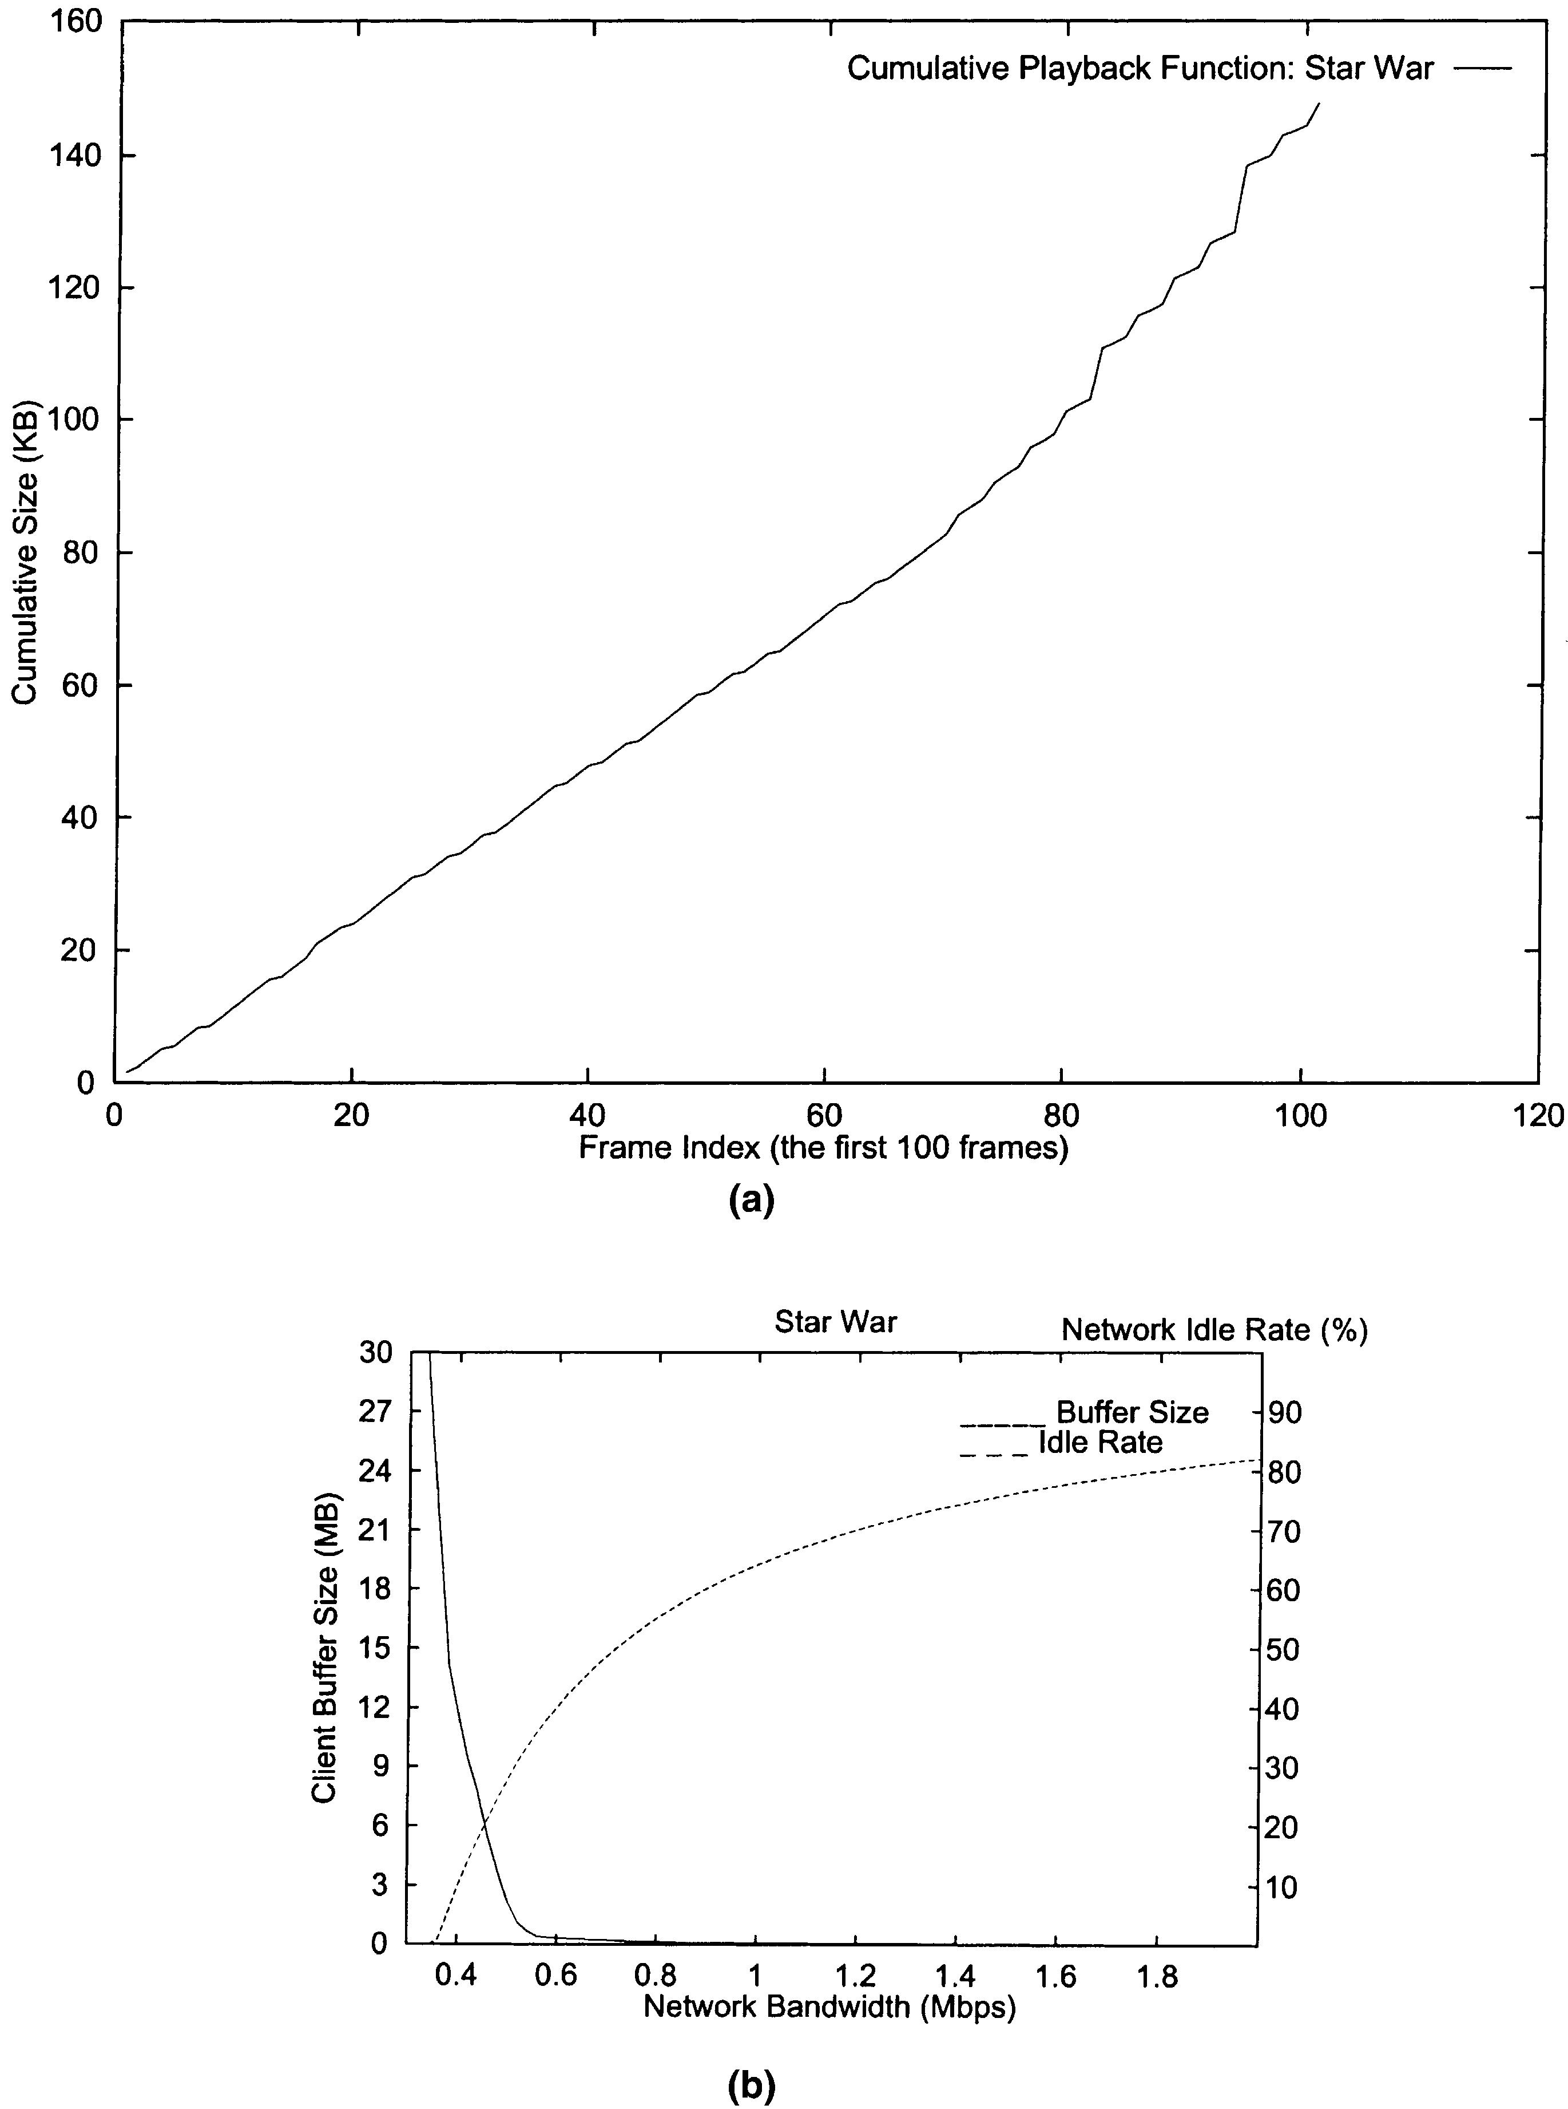

R.-I. Chang et al. / Information Sciences 141 (2002) 61–79

73

Fig. 7. Star War: (a) The cumulative playback function of the ﬁrst 100 frames. (b) The optimal
network bandwidth, buﬀer size and network idle rate obtained by our proposed algorithm.
cumulative playback function of the ﬁrst 100 frames of CNN News in Fig. 8(a).
The optimal resource allocation and utilization obtained are shown in Fig.
8(b). As the variance of frame sizes is small, the bandwidth-buﬀer-tradeoﬀ

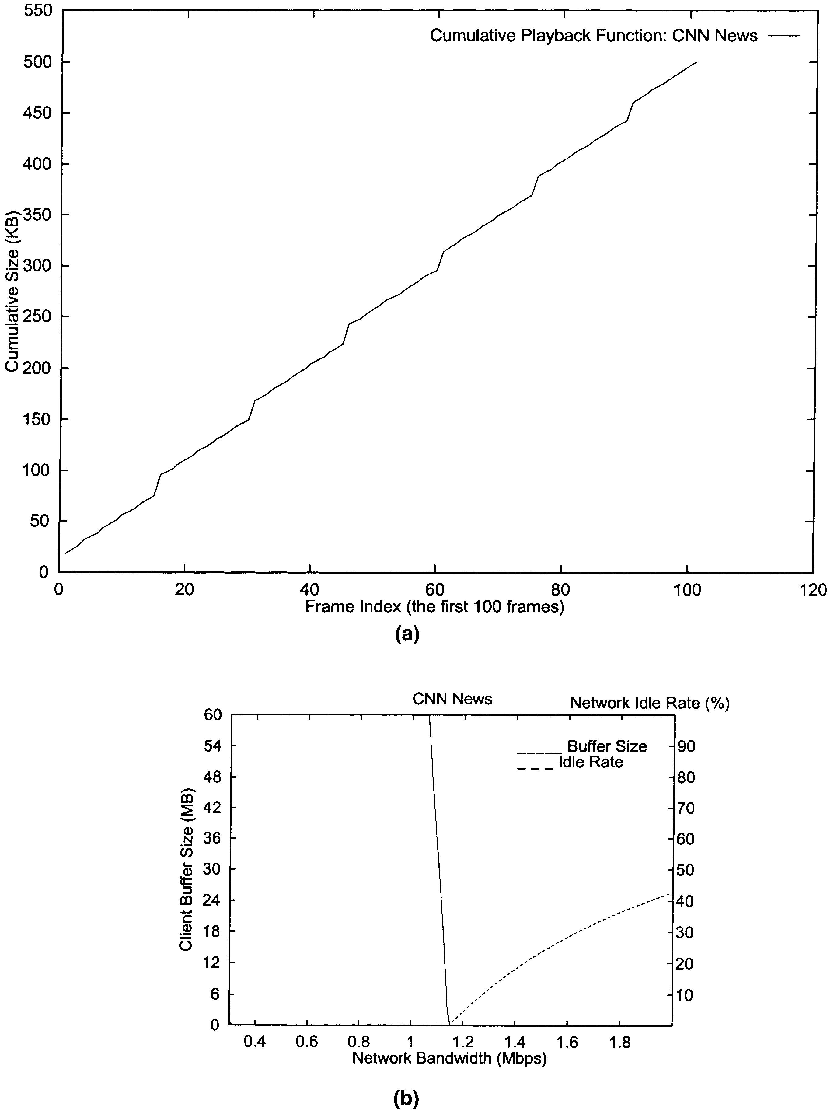

74

R.-I. Chang et al. / Information Sciences 141 (2002) 61–79

Fig. 8. CNN News: (a) The cumulative playback function of the ﬁrst 100 frames. (b) The optimal
network bandwidth, buﬀer size and network idle rate obtained by our proposed algorithm.

function is almost linear. Besides, the network idle rate is near zero when the
transmission bandwidth is lower than the average stream rate 1.15 Mbps. For
example, by applying the average stream rate as the transmission bandwidth,

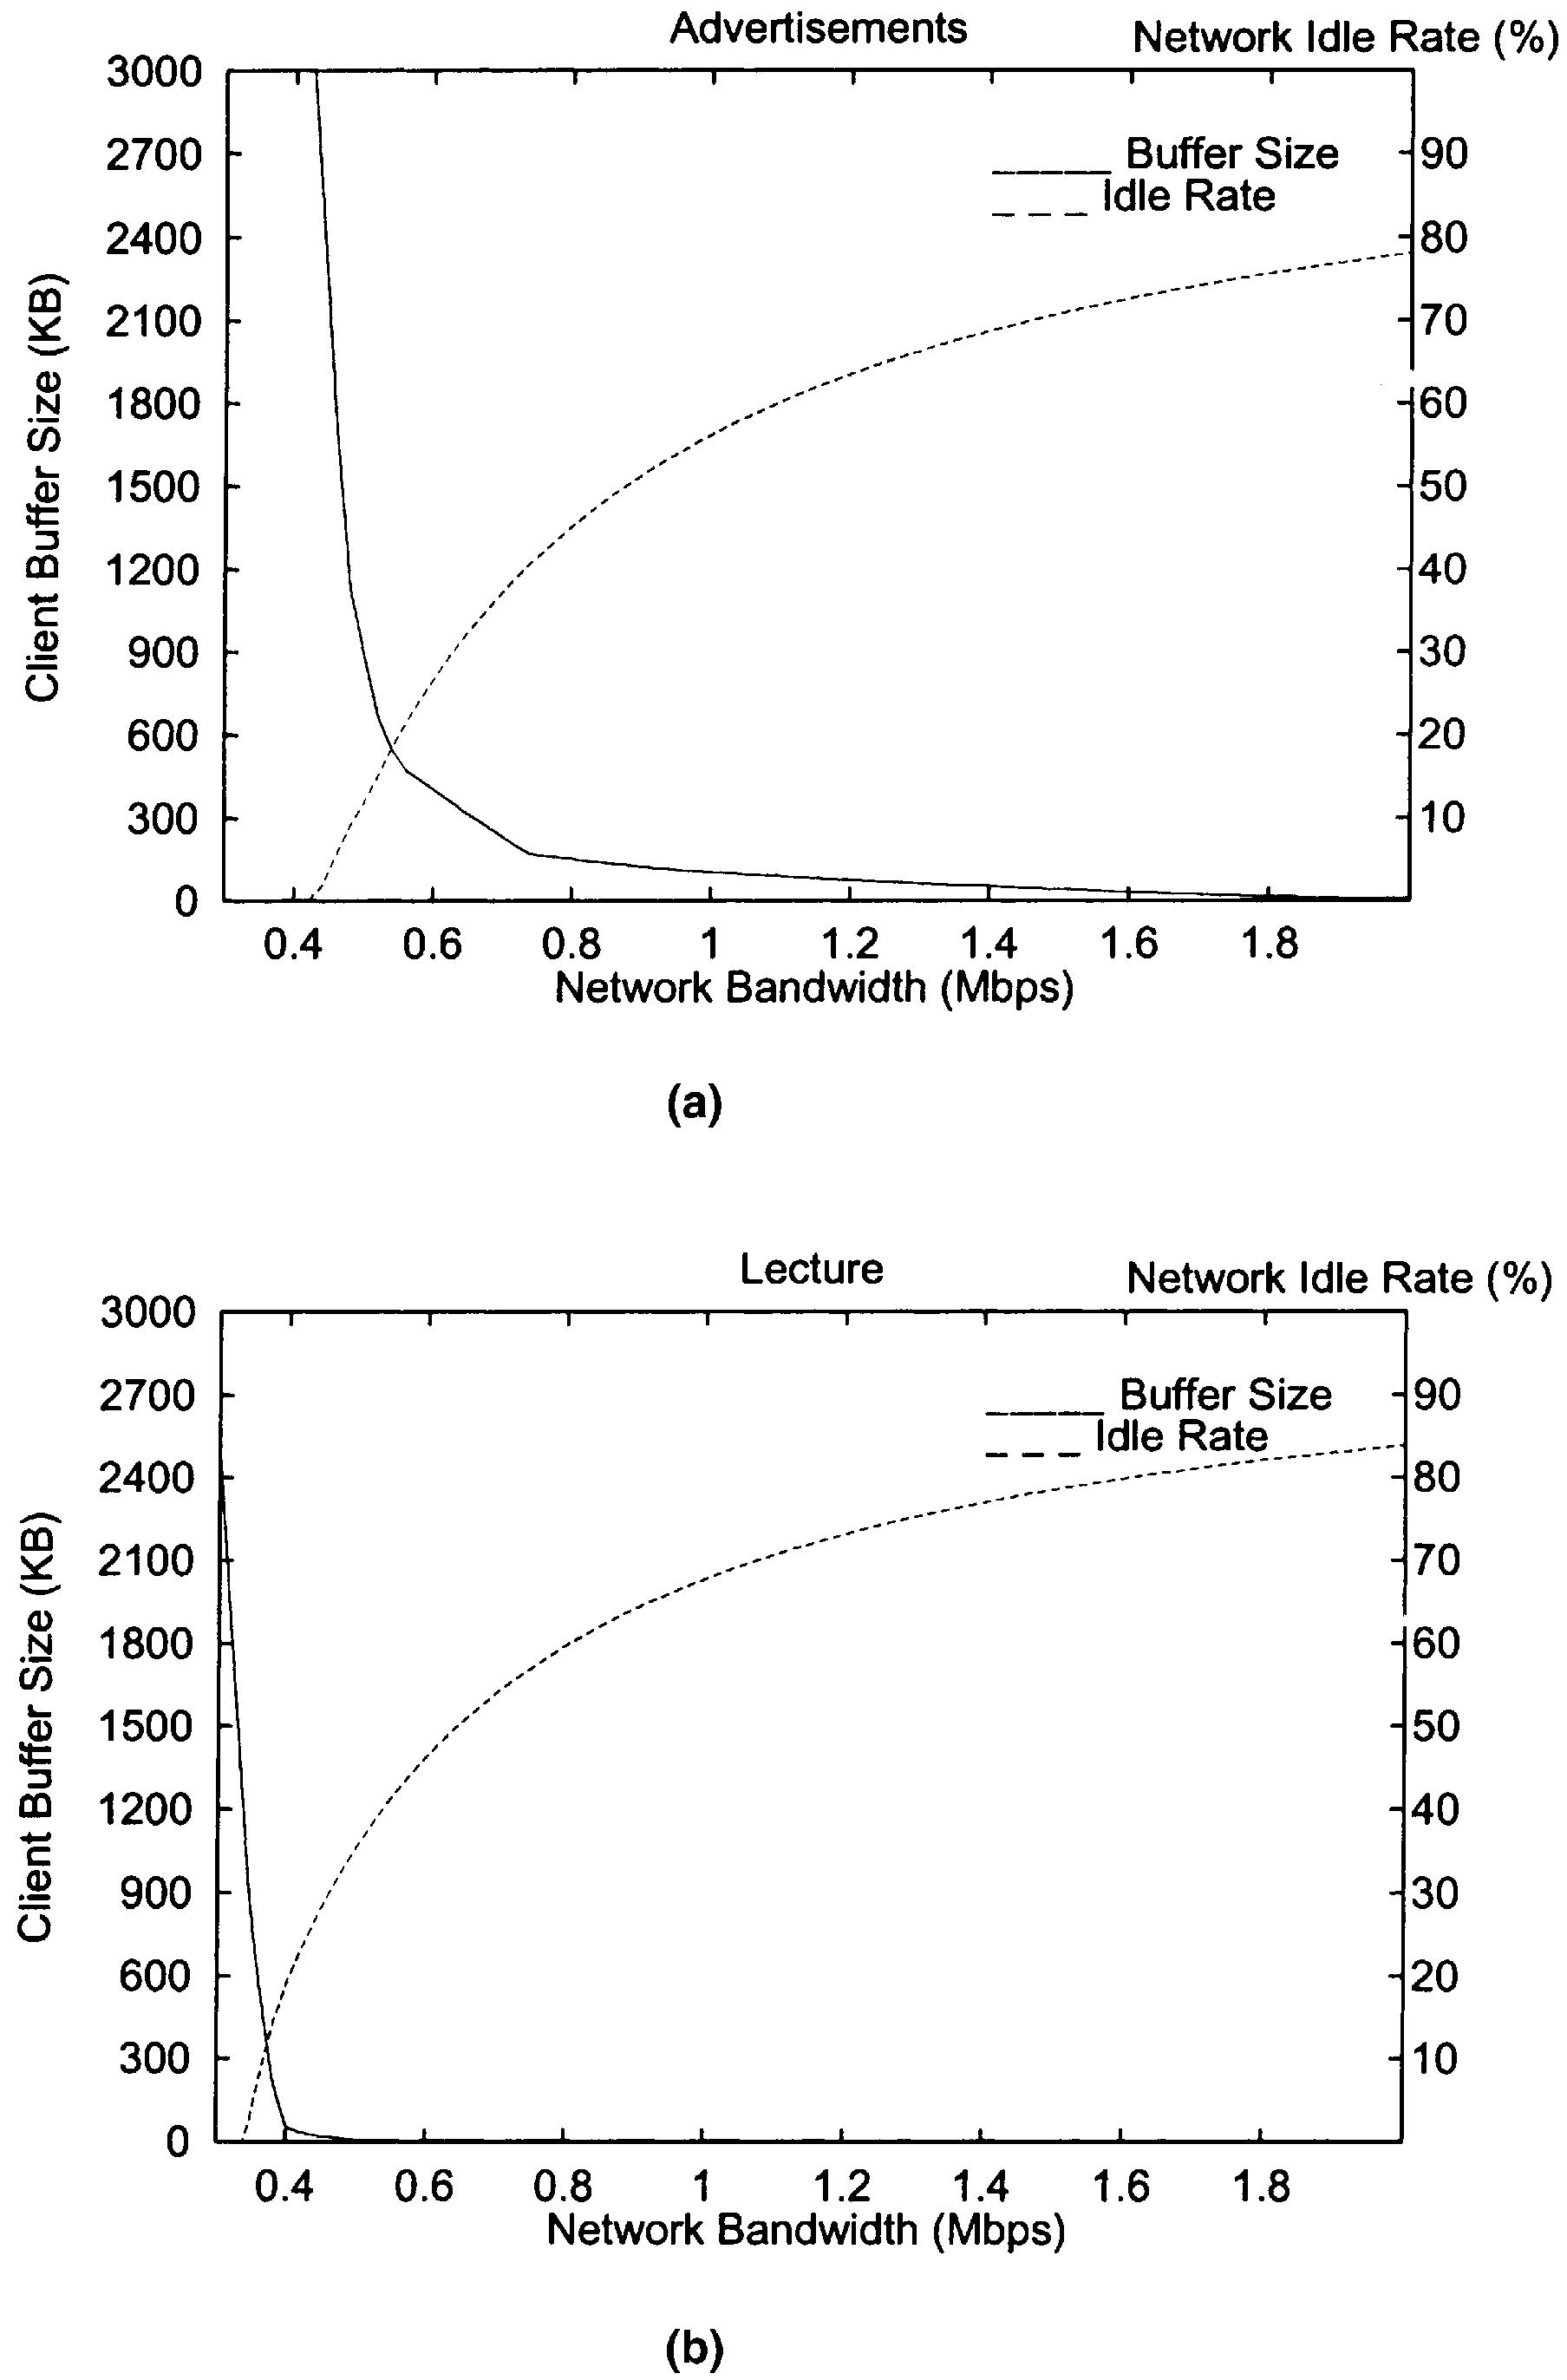

R.-I. Chang et al. / Information Sciences 141 (2002) 61–79

75

the client can continuously play CNN News with 38 KB memory buﬀer and 150
ms initial delay. On an OC-3 link, we can support over 110 users to watch CNN
News at the same time by the transmission schedule obtained. Comparing
Princess Bride and CNN News, the hardware coded streams have almost
identical statistics. The obtained results, i.e. the required transmission band-
width, network utilization, buﬀer size and initial delay, are almost the same.
Diﬀerent from the hardware coder, a software coder may introduce a high
variance in GoP sizes due to the video contents presented. In this paper, our
next two test examples are video traces Advertisements and Lecture encoded by
the UCB software MPEG coder [14]. Both of them are about 10 min long with
very diﬀerent contents. Lecture shows a speaker and slides with zooming and

Fig. 9. The optimal network bandwidth, buﬀer size and network idle rate obtained by our pro-
posed algorithm for (a) Advertisements and (b) Lecture.

76

R.-I. Chang et al. / Information Sciences 141 (2002) 61–79

panning. As the frame contents are similar, the variation of GoP sizes is small.
On the contrary, Advertisements contains a sequence of advertisements. It has
the diﬀerent frame contents from one scene to another scene. Therefore, the
variation of GoP sizes is large. Fig. 9(a) and (b) shows the optimal resource
allocation and utilization obtained for Advertisements and Lecture, respec-
tively. Our experiments conclude that the GoP sizes and their variations may
aﬀect the resources required for media transmission. The network bandwidth
and the network idle rate required for transmitting high-variance Advertise-
ments is larger than that required for transmitting low-variance Lecture under
the same client buﬀer size. The relations between the required buﬀer size and
the obtained network idle rate for diﬀerent streams, high-variance Advertise-
ments and low-variance Lecture, are compared in Fig. 10.
Although our approach has already proved optimal in resource allocation
and utilization, we would like to compare our optimal schedule results to the
schedule results obtained by previous approaches to measure the improve-
ments achieved. In Fig. 11, we compare the proposed algorithm to CRTT by
the client buﬀer required for transmitting Advertisement under diﬀerent initial
delays. Experiments show that, only when the initial delay is over 50 s, CRTT
can provide the similar buﬀer size as our approach obtained. Our improvement
in required buﬀer size is dramatic. Fig. 12 shows the comparisons of our
proposed algorithm and MVBA by network idle rate obtained under diﬀerent
initial delays. Note that, as MVBA requires pre-specifying buﬀer size and
initial delay to decide the related network bandwidth, it does not provide a way
to minimize both buﬀer size and initial delay at the same time. To do the fair
comparisons, the optimal buﬀer size and initial delay obtained by our approach

100
Advertisements
Lecture
80

60

40

20

0

0
50
100
150
200
250
300

Client Buffer Size (KB)
Fig. 10. The relations between the required buﬀer size and the obtained network idle rate for
diﬀerent streams, Advertisements and Lecture.

Netw
o
rk
Idle Rate (%)

R.-I. Chang et al. / Information Sciences 141 (2002) 61–79

Advertisements
8
proposed

77

7
6
5
4
3
2
1
0
CRTT

0 10 20 30 40 50 60 70
Initial Delay (sec)

Fig. 11. A comparison of the client buﬀer size required for our proposed algorithm and CRTT with
diﬀerent initial delay.

Advertisements
30
proposed

25

20

15

10

5

0
MVBA

0 10 20 30 40 50 60 70
Initial Delay (sec)

Fig. 12. A comparison of the network idle rate required for our proposed algorithm and MVBA
with diﬀerent initial delay.

are assigned as the given parameters to MVBA. Experiments show that our
approach is better than the MVBA approach in network utilization obtained.

5. Conclusion

In this paper, a traﬃc shaping scheme is introduced to decide the suitable
transmission schedules. Instead of giving a ﬁxed schedule result, our approach

Client Buff
e
r Siz
e
(MB)
Netw
or
k Idle Rate (%)

78

R.-I. Chang et al. / Information Sciences 141 (2002) 61–79

decides the schedulable region for all the transmission schedules that have the
optimal allocation and utilization in system resources. Experiments have
shown that our algorithm can achieve a dramatic improvement than the
conventional approaches in both the buﬀer size and the network idle rate.
Based on the schedulable region provided, the ready time and deadline are
precisely speciﬁed to each media packet to support real-time network sched-
uling and error control. The proposed approach is shown to be practical, ef-
ﬁcient, and ﬂexible in supporting continuous media transmission.

References

[1] T.M. Apostol, Math. Anal. (1973).
[2] E. Chang, A. Zakhor, Scalable video data placement on parallel disk arrays, in: IS & T/SPIE
Symposium on Electronic Imaging Science and Technology, Febraury 1994.
[3] R.I. Chang, M.C. Chen, J.M. Ho M.T. Ko, Designing the on-oﬀ CBR transmission schedule
for jitter-free VBR media playback in real-time networks, in: IEEE RTCSA, 1997, pp. 1–9.
[4] R.I. Chang, M.C. Chen, J.M. Ho, M.T. Ko, Optimizations of stored VBR video transmission
on CBR channel, in: SPIE VVDC, 1997, pp. 382–392.
[5] R.I. Chang, M.C. Chen, M.T. Ko, J.M. Ho, Characterize the minimum required resources for
admission control of pre-recorded VBR video transmission by an Oрn log nЮ, in: IEEE IC3N,
1998.
[6] R.I. Chang, M.C. Chen, J.M. Ho, M.T. Ko, An eﬀective and eﬃcient traﬃc smoothing scheme
for delivery of online VBR media streams, in: IEEE INFOCOM, 1999.
[7] R.I. Chang, W.K. Shih, R.C. Chang, A new real-time disk scheduling algorithm and its
application to multimedia systems, in: 5th IEEE IDMS, Lecture Notes on Computer Science,
1998.
[8] M. Chen, D.D. Kandlur, P.S. Yu, Optimization of the grouped sweeping scheduling (GSS)
with heterogeneous multimedia streams, in: ACM Multimedia Conference, 1993, pp. 235–242.
[9] W. Feng, F. Jahanian, S. Sechrest, Optimal buﬀering for the delivery of compressed
prerecorded video, in: IASTED International Conference on Networks, January 1996.
[10] W. Feng, S. Sechrest, Smoothing and buﬀering for delivery of prerecorded compressed video,
in: IS&T/SPIE Multimedia Computing and Networking, February 1995, pp. 234–244.
[11] M. Garrett, W. Willinger, Analysis, modeling and generation of self-similar VBR video traﬃc,
in: ACM SIGCOMM, August 1994, pp. 269–280.
[12] M. Grossglauser, S. Keshav, On CBR service, in: IEEE INFOCOM, March 1996.
[13] M. Grossglauser, S. Keshav, D. Tse, RCBR: a simple and eﬃcient service for multiple time-
scale traﬃc, in: ACM SIGCOMM, August 1995.
[14] E.W. Knightly, D.E. Wrege, J. Liebeherr, H. Zhang, Fundamental limits and tradeoﬀs of
providing deterministic guarantees to VBR video traﬃc, in: ACM SIGMETRICS, May 1995,
pp. 98–107.
[15] M. Krunz, H. Hughes, A traﬃc model for mpeg-coded VBR streams, in: ACM SIGMET-
RICS, May 1995, pp. 47–55.
[16] S.S. Lam, S. Chow, D.K.Y. Yau, An algorithm for lossless smoothing of MPEG video, in:
ACM SIGCOMM, 1994.
[17] T. Ott, T.V. Lakshman, A. Tabatabai, A scheme for smoothing delay-sensitive traﬃc oﬀered
to ATM networks, in: IEEE INFOCOM, 1992.
[18] A.R. Reibman, A.W. Berger, Traﬃc descriptors for VBR video teleconferencing over ATM
networks, in: IEEE/ACM Trans. Networking, June 1995.

R.-I. Chang et al. / Information Sciences 141 (2002) 61–79

79

[19] J.M. McManus, K.W. Ross, Video on demand over ATM: Constant-rate transmission and
transport, in: IEEE INFOCOM, March 1996.
[20] J.D. Salehi, Z.L. Zhang, J.F. Kurose, and D. Towsley, Supporting stored video: reducing rate
variability and end-to-end resource requirements through optimal smoothing, in: Proceedings
ACM SIGMETRICS, 1996.
[21] K. Sohraby, On the theory of general on-oﬀ source with applications in high-speed networks,
in: IEEE INFOCOM, 1993, pp. 401–410.
[22] FTP ftp::/thumper.bellcore.com.
[23] URL http::/www.eeb.ele.tue.nl/mpeg/.
[24] Y.C. Wang, S.L. Tsao, R.I. Chang, M.C. Chen, J.M. Ho, M.T. Ko, A fast data placement
scheme for video server with zoned-disks, in: SPIE VVDC, 1997, pp. 92–102.
[25] H. Zhang, E.W. Knightly, A new approach to support delay-sensitive VBR video in packet-
switched networks, in: IEEE NOSSDAV, 1995.
[26] J. Zhang, J. Hui, Traﬃc characteristics and smoothness criteria in VBR video traﬃc
smoothing, in: IEEE ICMCS, June 1997, pp. 3–11.
[27] R.I. Chang, W.K. Shih, R.C. Chang, Real-time disk scheduling for multimedia applications
with deadline-modiﬁcation-scan scheme, Real-time Syst. 19 (2) (2000) 149–168.
[28] R.I. Chang, C.L. Chen, W.K. Shih, R.C. Chang, Design and implementation of a real-time
disk scheduling algorithm by the multi-segment cascade scheme, in: IEEE RTSS (WIP) 1999,
pp. 1–5.

